- FIR FILTER DESIGN
Aim:- To design and simulate FIR filter using any windowing Technique.
Software Required:- Pc with MATLAB 7.6.0.
Specifications:-
Cut-off frequencies:
wc=π/2
wc1=π/4
wc2=3π/4
Ripples:
Pass band = 0.02dB
Stop band = 0.01dB
Frequencies:
Pass band = 1200Hz
Stop band = 1700Hz
Sampling = 9000Hz
Theory:-
FIR filter are of non-recursive type, where by the present output sample depends on the present input sample and previous input samples.
The transfer function of FIR causal filter is given by
H(z)=
h(n) is the impulse response of the filter
The Fourier transform of h(n) is
H()=
The magnitude response of Lowpass filter with specifications is shown below.
δp - Passband ripple
δs - Stopband ripple
fp - Passband edge frequency
fs - Stopband edge frequency
Fs – Sampling frequency
In the design of FIR filters using any window technique, the order can be calculated using the formula given by
N=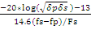

Design of FIR filters using window Techniques:-
The Design frequency response Hd() of a filter is periodic in frequency and can be expanded in fourier services. The resultant services is given by
Hd()=
Where hd(n)=)dw
One possible way of obtaining FIR filter is to truncate the infinite Fourier series at n=, where N is the length of the desired sequence. But abrupt truncation of the Fourier series results in oscillation in the pass band and stop band. There oscillations are due to slow convergence of the Fourier services and this effect is known as the Gibbs phenomenon.
To reduce these oscillations, the Fourier coefficients of the filter are modified by multiplying the infinite impulse response with a finite weighting sequence w(n) called a window where
w(n) = w(-n) ≠ 0 for |n|<=
w(n) = w(-n) =0 for |n|>
After multiplying window sequence w(n) with hd(n), we get a finite duration sequence h(n) that satisfies the desired magnitude response.
H(n) = hd(n)w(n) for all |n|<=
= 0 for |n| >
The frequency response is H() of the filter can be obtained by convolution of Hd() and w(
H(
= Hd()*w(
Because both Hd( and w( are periodic functions the operation is often called as periodic convolution.
The frequency response of the filter H() depends on the frequency response of window w( therefore, the window, chosen after truncating the infinite impulse response should here some desirable characteristics. They are
- The central lobe of the frequency response of the window should contain most of the energy and should be narrow.
- The highest side lobe level of the frequency response should be small.
- The side lobes of the frequency response should decrease in energy rapidly as w tends to π.
Program:-
% MATLAB program for FIR filter design using window techniques
- Hanning window:-

clc;
clear all;
close all;
rp=input('enter the pass band ripple = ');
rs=input('enter the stop band ripple = ');
fp=input('enter the pass band frequency in hz = ');
fs=input('enter the stop band frequency in hz= ');
f=input(' enter the sampling frequency in hz ');
wp=2*fp/f;
ws=2*fs/f;
num=-20*log10(sqrt(rp*rs))-13;
dem=14.6*(fs-fp)/f;
n=ceil(num/dem);
n1=n+1;
if(rem(n,2)~=0)
n1=n;
n=n-1;
end
y=hanning(n1);
b=fir1(n,wp,y);
[h,o]=freqz(b,1,256);
m=20*log10(abs(h));
subplot(2,2,1);
plot(o/pi,m);
ylabel('gain in db ');
xlabel('(a) normalized frequency ');
b=fir1(n,wp,'high',y);
[h,o]=freqz(b,1,256);
m=20*log10(abs(h));
subplot(2,2,2);
plot(o/pi,m);
ylabel('gain in db ');
xlabel('(b) normalized frequency ');
wn=[wp ws];
b=fir1(n,wn,y);
[h,o]=freqz(b,1,256);
m=20*log10(abs(h));
subplot(2,2,3);
plot(o/pi,m);
ylabel('gain in db ');
xlabel('(c) normalized frequency ');
b=fir1(n,wn,'stop',y);
[h,o]=freqz(b,1,256);
m=20*log10(abs(h));
subplot(2,2,4);
plot(o/pi,m);
ylabel('gain in db ');
xlabel('(d) normalized frequency ');

Input values:-

enter the pass band ripple = 0.02
enter the stop band ripple = 0.01
enter the pass band frequency in hz = 1400
enter the stop band frequency in hz= 2000
enter the sampling frequency in hz 8000

Output waveforms:-

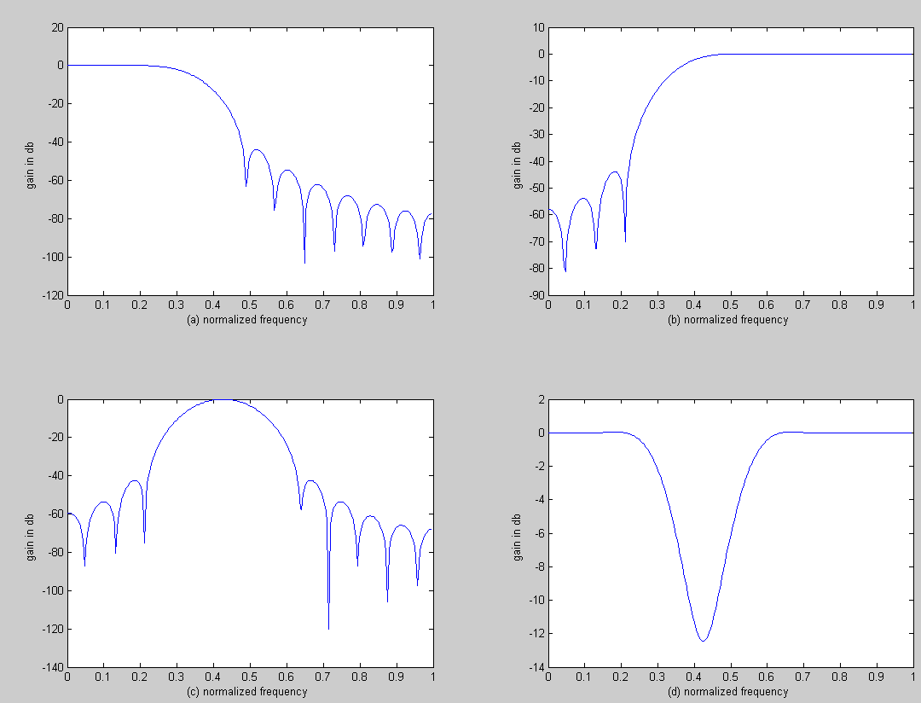

- Hamming window:-

clc;
clear all;
close all;
rp=input('enter the pass band ripple = ');
rs=input('enter the stop band ripple = ');
fp=input('enter the pass band frequency in hz = ');
fs=input('enter the stop band frequency in hz= ');
f=input(' enter the sampling frequency in hz ');
wp=2*fp/f;
ws=2*fs/f;
num=-20*log10(sqrt(rp*rs))-13;
dem=14.6*(fs-fp)/f;
n=ceil(num/dem);
n1=n+1;
if(rem(n,2)~=0)
n1=n;
n=n-1;
end
y=hamming(n1);
b=fir1(n,wp,y);
[h,o]=freqz(b,1,256);
m=20*log10(abs(h));
subplot(2,2,1);
plot(o/pi,m);
ylabel('gain in db ');
xlabel('(a) normalized frequency ');
b=fir1(n,wp,'high',y);
[h,o]=freqz(b,1,256);
m=20*log10(abs(h));
subplot(2,2,2);
plot(o/pi,m);
ylabel('gain in db ');
xlabel('(b) normalized frequency ');
wn=[wp ws];
b=fir1(n,wn,y);
[h,o]=freqz(b,1,256);
m=20*log10(abs(h));
subplot(2,2,3);
plot(o/pi,m);
ylabel('gain in db ');
xlabel('(c) normalized frequency ');
b=fir1(n,wn,'stop',y);
[h,o]=freqz(b,1,256);
m=20*log10(abs(h));
subplot(2,2,4);
plot(o/pi,m);

ylabel('gain in db ');
xlabel('(d) normalized frequency ');

Input values:-

enter the pass band ripple = 0.02
enter the stop band ripple = 0.01
enter the pass band frequency in hz = 1200
enter the stop band frequency in hz= 1700
enter the sampling frequency in hz =9000

Output waveforms:-

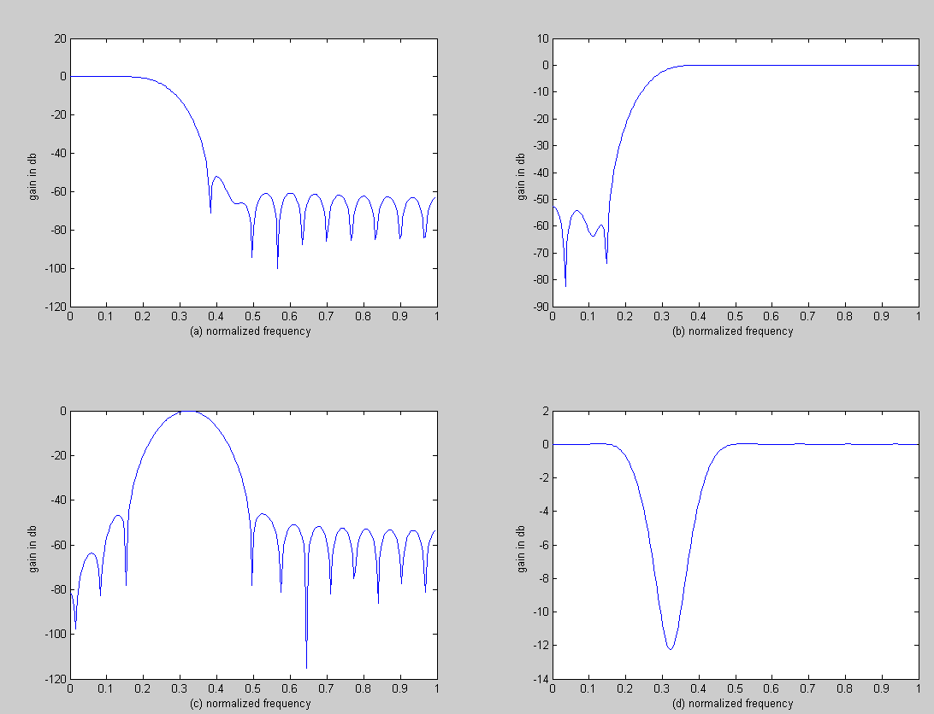

- Kaiser window:-

clc;
clear all;
close all;
rp=input('enter the pass band ripple = ');
rs=input('enter the stop band ripple = ');
fp=input('enter the pass band frequency in hz = ');
fs=input('enter the stop band frequency in hz= ');
f=input(' enter the sampling frequency in hz ');
beta=input('enter the beta value ');
wp=2*fp/f;
ws=2*fs/f;
num=-20*log10(sqrt(rp*rs))-13;
dem=14.6*(fs-fp)/f;
n=ceil(num/dem);
n1=n+1;
if(rem(n,2)~=0)
n1=n;
n=n-1;
end
y=kaiser(n1,beta);
b=fir1(n,wp,y);
[h,o]=freqz(b,1,256);
m=20*log10(abs(h));
subplot(2,2,1);
plot(o/pi,m);
ylabel('gain in db ');
xlabel('(a) normalized frequency ');
b=fir1(n,wp,'high',y);
[h,o]=freqz(b,1,256);
m=20*log10(abs(h));
subplot(2,2,2);
plot(o/pi,m);
ylabel('gain in db ');
xlabel('(b) normalized frequency ');
wn=[wp ws];
b=fir1(n,wn,y);
[h,o]=freqz(b,1,256);
m=20*log10(abs(h));
subplot(2,2,3);
plot(o/pi,m);
ylabel('gain in db ');
xlabel('(c) normalized frequency ');
b=fir1(n,wn,'stop',y);
[h,o]=freqz(b,1,256);
m=20*log10(abs(h));
subplot(2,2,4);

plot(o/pi,m);
ylabel('gain in db ');
xlabel('(d) normalized frequency ');

Input values:-

enter the pass band ripple = 0.02
enter the stop band ripple = 0.01
enter the pass band frequency in hz = 1000
enter the stop band frequency in hz= 1500
enter the sampling frequency in hz 10000
enter the beta value = 8

Output waveforms:-

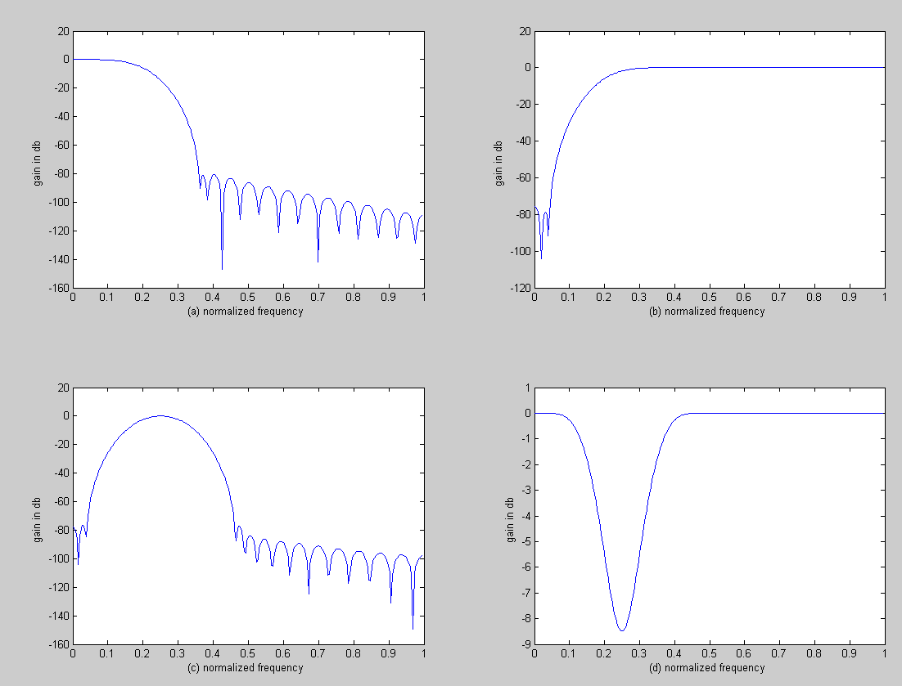

- rectangular window:-

clc;
close all;
clear all;
rp=input('enter the pass band ripple');
rs=input('enter the stop band ripple');
fp=input('enter the pass band frequency');
fs=input('enter the stop band frequency');
f=input('enter the sampling frequency');
wp=2*(fp/f);
ws=2*(fs/f);
num=-20*log10(sqrt (rp*rs))-13;
dem=14.6*(fs-fp)/f;
n=ceil(num/dem);
n1=n+1;
if(rem(n,2)~=0)
n1=n;n=n-1;
end
y=bartlett(n1);
b=fir1(n,wp,y);figure,freqz(b,1,256);
b=fir1(n,ws,'high',y);figure,freqz(b,1,256);
wn=[wp ws];
b=fir1(n,wn,y);figure,freqz(b,1,256);
b=fir1(n,wn,'stop',y);figure,freqz(b,1,256);

Input Values:-

enter the pass band ripple = 0.02
enter the stop band ripple = 0.01
enter the pass band frequency = 1000
enter the stop band frequency = 1500
enter the sampling frsquency = 10000

Output waveforms:-

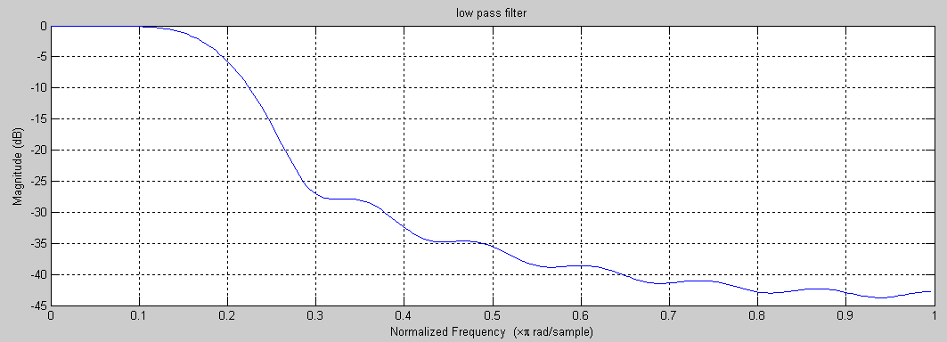

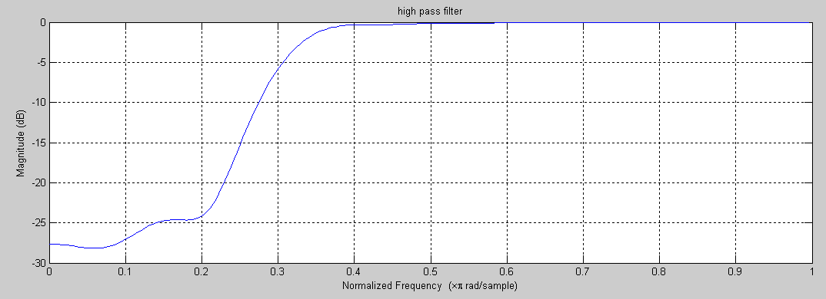

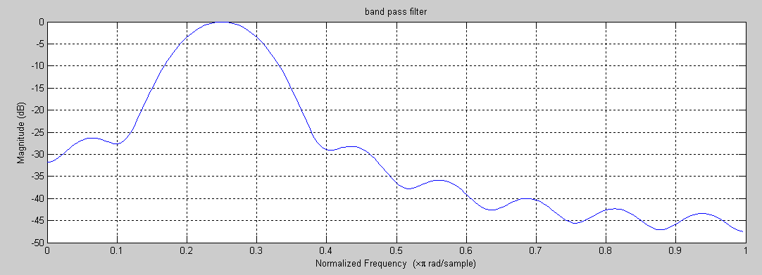

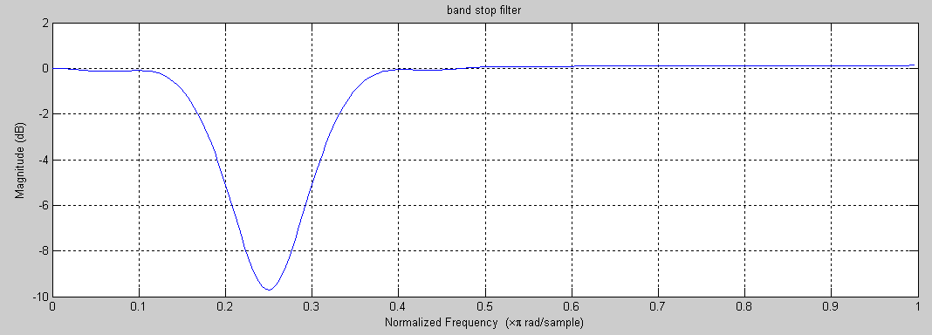

- Triangular window:-

clc;
close all;
clear all;
rp=input('enter the pass band ripple');
rs=input('enter the stop band ripple');
fp=input('enter the pass band frequency');
fs=input('enter the stop band frequency');
f=input('enter the sampling frequency');
wp=2*(fp/f);
ws=2*(fs/f);
num=-20*log10(sqrt (rp*rs))-13;
dem=14.6*(fs-fp)/f;
n=ceil(num/dem);
n1=n+1;
if(rem(n,2)~=0)
n1=n;n=n-1;
end
y=bartlett(n1);
b=fir1(n,wp,y);figure,freqz(b,1,256);
b=fir1(n,ws,'high',y);figure,freqz(b,1,256);
wn=[wp ws];
b=fir1(n,wn,y);figure,freqz(b,1,256);
b=fir1(n,wn,'stop',y);figure,freqz(b,1,256);

Input values:-

enter the pass band ripple = 0.02
enter the stop band ripple = 0.01
enter the pass band frequency in hz = 1200
enter the stop band frequency in hz= 1700
enter the sampling frequency in hz =9000

Output waveforms:-

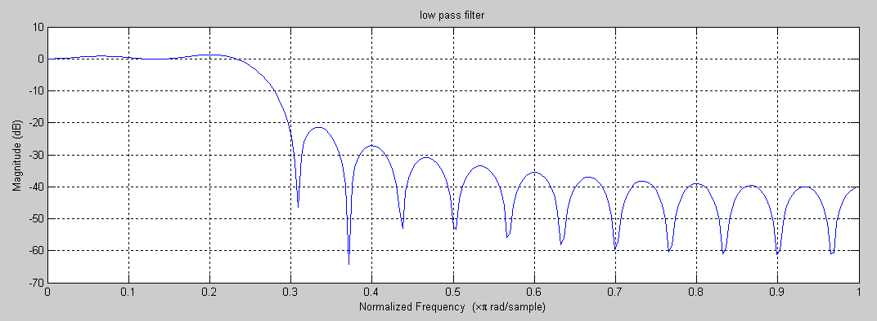

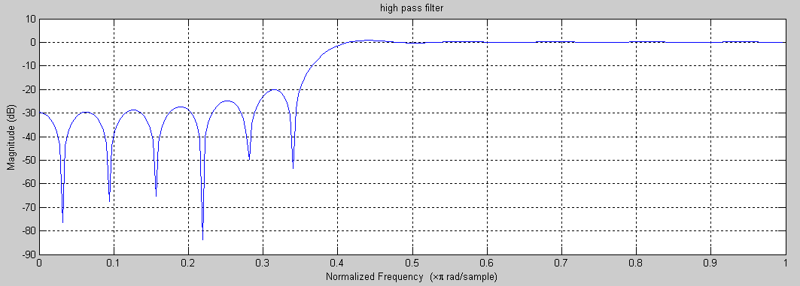

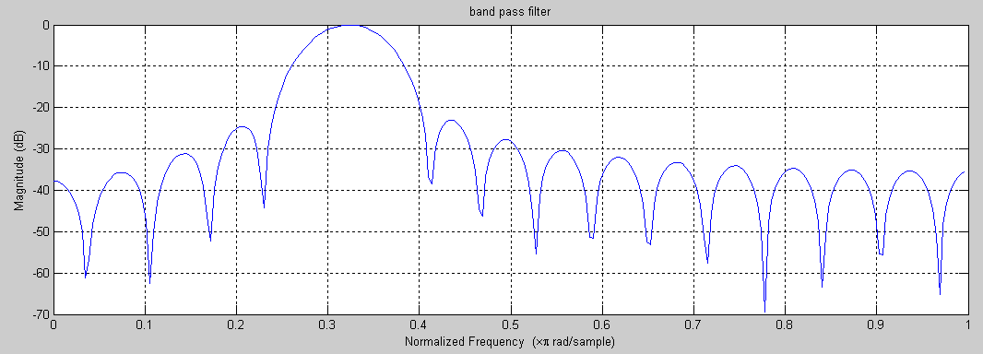

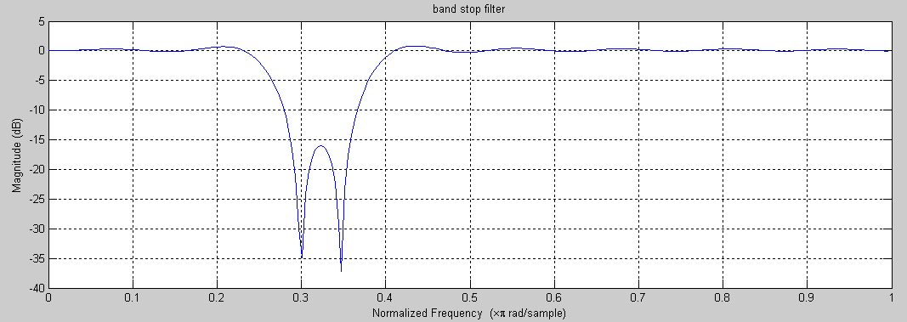

Result:-
The design and simulation of an FIR Filter using windowing techniques is simulated and waveforms are verified.

2 .IIR FILTER DESIGN

Aim:- To design IIR filters from Analog filters.
Software Required:- Pc with MATLAB 7.6.0
Theory:- IIR filters are to recursive type, where by the present output sample depends on the present input, past input samples and output samples.
IIR digital filters have the transfer function of the form
H(z)= = 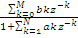
The most common technique used for designing IIR digital filters known as indirect method, involves first designing analog filter and then transforming to a digital filter. For the given specifications of a digital filter T/F requires 3 steps.
- Map the desired digital filter specification into those for an equivalent analog filter.
- Derive the analog transfer function for the analog prototype.
- Transform the Transfer function of the analog prototype into an equivalent digital filter transfer function.
Specifications of Magnitude response of a low pass filter is shown in fig:
Wp – Pass band frequency in radians.
Ws – Stop band Frequency in radians.
Wc – 3-db cutoff frequency in radians.
Є - parameter specifying allowable pass band.
λ - parameter specifying allowable stop band.
Design of IIR filters from analog filters:-
There are several methods that can be used to design digital filters having as infinite duration unit sample response. The techniques described are all based on converting an analog filter into a digital filter. If the conversation technique is to be effective, it should posses the following desirable properties.
- The jΩ-axis in the s-plane should map in to the unit circle in the z-plane. Thus there will be a direct relationship between the two frequency variables in the two domains.
- The Left-half plane of the s-plane should map into the inside of the unit circle in the z-plane. Thus a stable analog filter will be converted to a stable digital filter.
- The four most widely used methods for digitizing the analog filter into a digital filter include.
- Approximation of derivatives.
- The impulse invariant transformation.
- The bilinear transformation.
- The matched z-transformation technique.

Design of IIR filter using Bilinear Transformation:-
The bilinear transformation is a conformal mapping that transforms the jΩ axis into the unit circle in the z-plane only once, thus avoiding aliasing of frequency components. Furthermore, all points in the LHP of ‘s’ are mapped inside the unit circle in the z-plane and all points in the RHP of ‘s’ are mapped into corresponding points outside the unit circle in the z-plane.
Steps to design digital filter using bilinear transform technique:-
- From the given specifications, find pre-warping analog frequencies using formula

Ω=2/T*tanw/2
- Using the analog frequencies find H(s) of the analog filter.
- Select the sampling rate of the digital filter, call it T seconds per sample.
- Substitute s=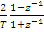 into the transfer function found in step2.

Program:-
% ------- MATLAB program for IIR filters design ------%

- Butter worth low pass filter:-

alphap=input('enter the pass band attenuation in db = ');
alphas=input('enter the stop band attenuation in db = ');
fs=input('enter the stop band frequency in hz = ');
fp=input('enter the pass band frequency in hz= ');
f=input(' enter the sampling frequency in hz ');
omp=2*fp/f;
oms=2*fs/f;
[n,wn]=buttord(omp,oms,alphap,alphas);
[b,a]=butter(n,wn);
w=0:0.01:pi;
[h,om]=freqz(b,a,w,'whole');
gain=20*log10(abs(h));
ang=angle(h);
subplot(2,1,1);
plot(om/pi,gain);
grid;
xlabel('narmalized frequency in hz');
ylabel('gain in db');
title('anolog lowpass filter');
subplot(2,1,2);
plot(om/pi,ang);

grid;
ylabel('phase in radians');
xlabel('normalized frequency in hz ');

Input values:-

enter the pass band attenuation in db = 0.15
enter the stop band attenuation in db = 60
enter the stop band frequency in hz = 1500
enter the pass band frequency in hz= 3000
enter the sampling frequency in hz =7000

Output waveform:-

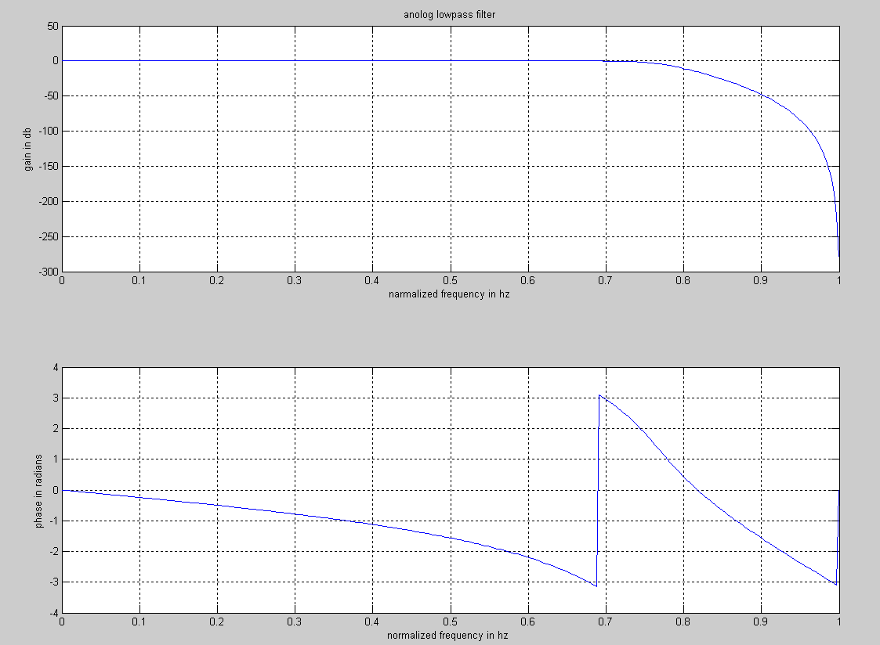

- Butter worth high pass filter:-
alphap=input('enter the pass band attenuation in db = ');
alphas=input('enter the stop band attenuation in db = ');
fs=input('enter the stop band frequency in hz = ');
fp=input('enter the pass band frequency in hz= ');
f=input(' enter the sampling frequency in hz ');
omp=2*fp/f;
oms=2*fs/f;
[n,wn]=buttord(omp,oms,alphap,alphas);
[b,a]=butter(n,wn,'high');
w=0:0.01:pi;
[h,om]=freqz(b,a,w,'whole');
gain=20*log10(abs(h));
ang=angle(h);
subplot(2,1,1);
plot(om/pi,gain);
grid;
xlabel('narmalized frequency in hz');
ylabel('gain in db');
title('anolog highpass filter');
subplot(2,1,2);
plot(om/pi,ang);
grid;
ylabel('phase in radians');
xlabel('normalized frequency in hz ');

Input values:-

enter the pass band attenuation in db = 0.2
enter the stop band attenuation in db = 40
enter the stop band frequency in hz = 2000
enter the pass band frequency in hz= 3500
enter the sampling frequency in hz = 8000

Output waveforms:-

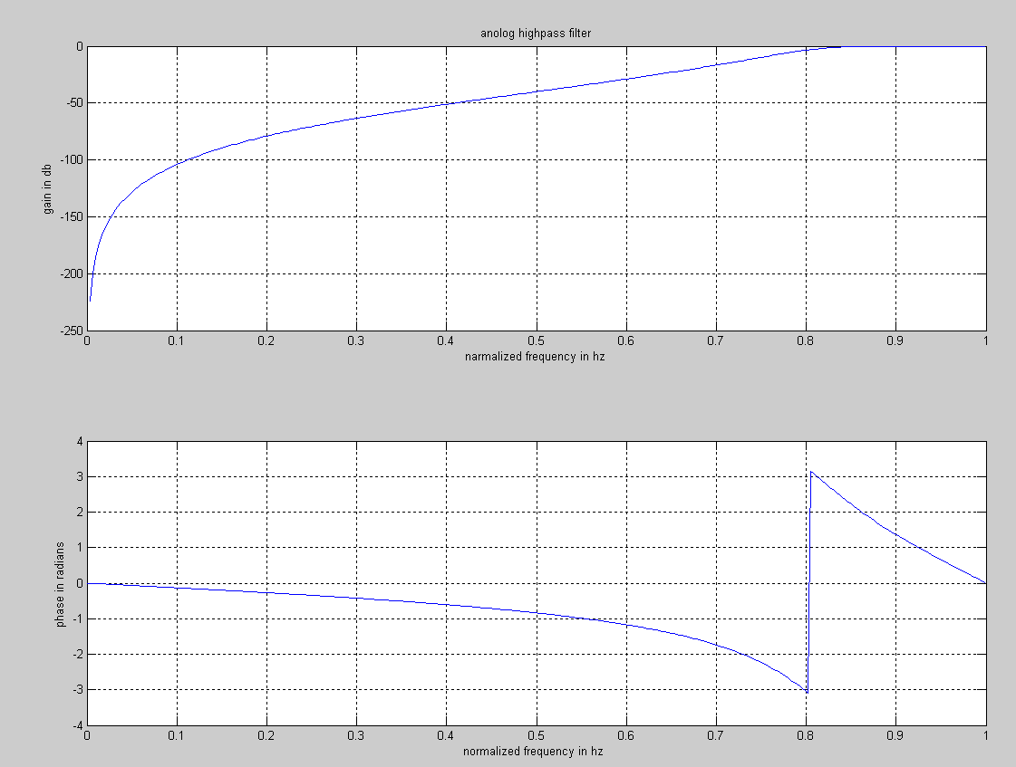

- Butter worth band pass filter:-

clc;
clear all;
format long;
rp=input('enter the pass band ripple = ');
rs=input('enter the stop band ripple = ');
ws=input('enter the stop band frequency in hz = ');
wp=input('enter the pass band frequency in hz= ');
fs=input(' enter the sampling frequency in hz =+');
w1=2*wp/fs;
w2=2*ws/fs;
[n]=buttord(w1,w2,rp,rs,'s');
wn=[w1 w2];
[b,a]=butter(n,wn,'bandpass','s');
w=0:0.01:pi;
[h,om]=freqz(b,a,w);
m=20*log10(abs(h));
an=angle(h);
subplot(2,1,1);
plot(om/pi,m);

grid;
xlabel('(a) narmalized frequency in hz');
ylabel('gain in db');
title('anolog bandpass filter');
subplot(2,1,2);
plot(om/pi,an);
grid;
ylabel('phase in radians');
xlabel('(b) normalized frequency in hz ');

Input values:-

enter the value of pass band ripple :0.2
enter the value of stop band ripple :40
enter the value of pass band frequency:2000
enter the value of stop band frequency :3500
enter the value of sampling frequency :8000

Output waveforms:-

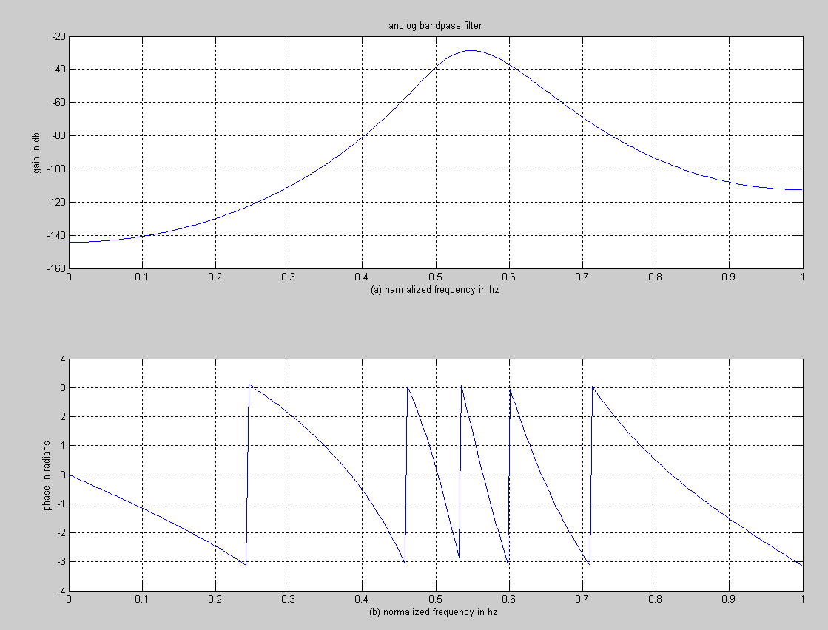

- Butter worth band stop filter:-

clc;
clear all;
close all;
format long;
rp=input('enter the pass band ripple = ');
rs=input('enter the stop band ripple = ');
wp=input('enter the pass band frequency in hz= ');
ws=input('enter the stop band frequency in hz = ');
fs=input(' enter the sampling frequency in hz =');
w1=2*wp/fs;
w2=2*ws/fs;
[n]=buttord(w1,w2,rp,rs,'s');
wn=[w1 w2];
[b,a]=butter(n,wn,'stop','s');
w=0:0.01:pi;
[h,om]=freqs(b,a,w);
m=20*log10(abs(h));
an=angle(h);
subplot(2,1,1);
plot(om/pi,m);
grid;
xlabel('(a) narmalized frequency in hz');
ylabel('gain in db');
title('anolog bandstop filter');
subplot(2,1,2);
plot(om/pi,an);
grid;
ylabel('phase in radians');
xlabel('(b) normalized frequency in hz ');

Input values:-

enter the value of pass band ripple = 0.2
enter the value of stop band ripple = 40
enter the value of pass band frequency in hz= 2000
enter the value of stop band frequency in hz = 3500
enter the value of sampling frequency in hz =8000

Output waveforms:-

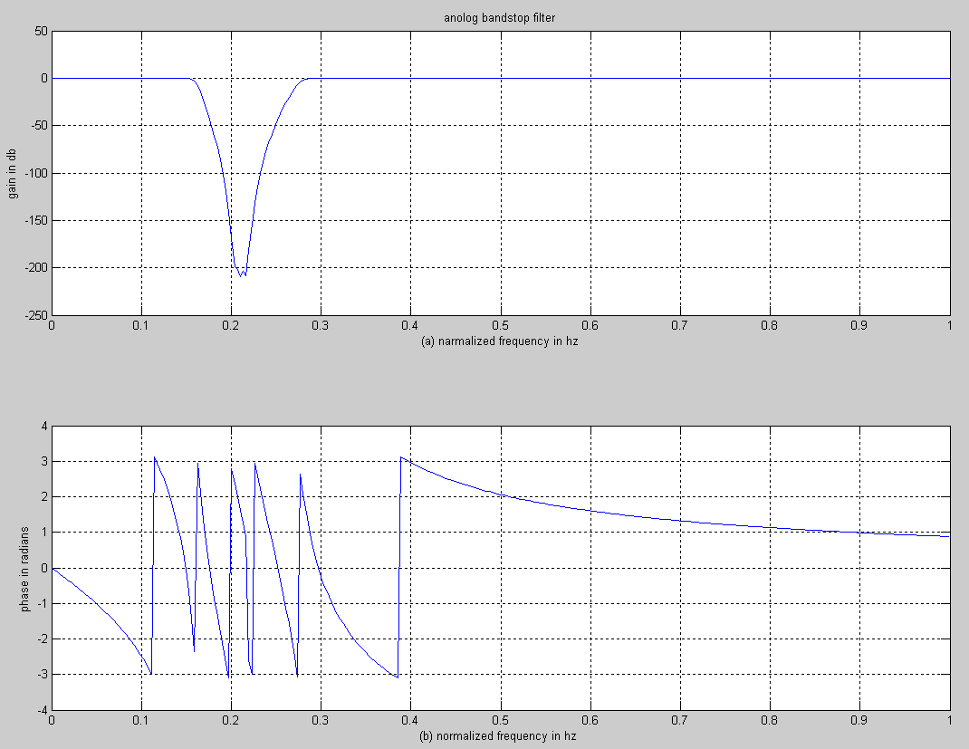

- Chebyshev type-1 lowpass filter:-

alphap=input('enter the pass band attenuation in db = ');
alphas=input('enter the stop band attenuation in db = ');
wp=input('enter the stop band frequency in rad = ');
ws=input('enter the pass band frequency in rad= ');
[n,wn]=cheb1ord(wp/pi,ws/pi,alphap,alphas);
[b,a]=cheby1(n,alphap,wn);
w=0:0.01:pi;
[h,om]=freqz(b,a,w);
gain=20*log10(abs(h));
ang=angle(h);
subplot(2,1,1);
plot(om/pi,gain);
grid;
xlabel('narmalized frequency in hz');
ylabel('gain in db');
title('anolog lowpass filter');
subplot(2,1,2);
plot(om/pi,ang);

grid;
ylabel('phase in radians');
xlabel('normalized frequency in hz ');

Input values:-

enter the pass band attenuation in db = 1
enter the stop band attenuation in db = 15
enter the stop band frequency in rad = 0.2*pi
enter the pass band frequency in rad= 0.3*pi

Output waveforms:-

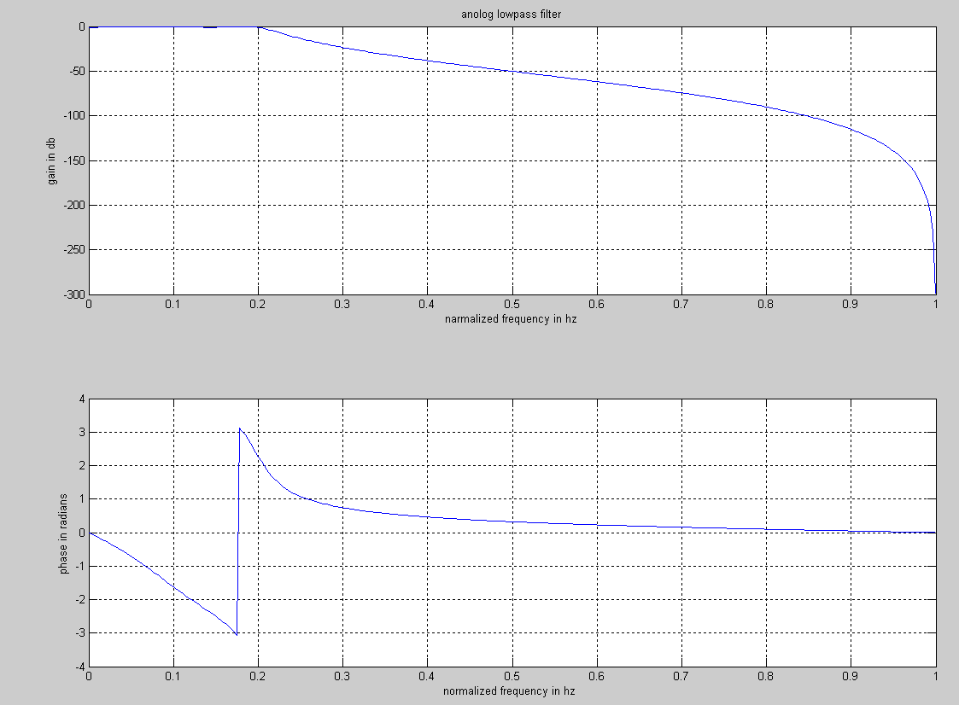

- Cheybyshev type2 lowpass filter :-

alphap=input('enter the pass band attenuation in db = ');
alphas=input('enter the stop band attenuation in db = ');
wp=input('enter the stop band frequency in rad = ');
ws=input('enter the pass band frequency in rad= ');
[n,wn]=cheb2ord(wp/pi,ws/pi,alphap,alphas);
[b,a]=cheby2(n,alphap,wn);
w=0:0.01:pi;
[h,om]=freqz(b,a,w);
gain=20*log10(abs(h));
ang=angle(h);
subplot(2,1,1);
plot(om/pi,gain);
grid;
xlabel('narmalized frequency in hz');
ylabel('gain in db');
title('anolog lowpass filter');
subplot(2,1,2);
plot(om/pi,ang);
grid;
ylabel('phase in radians');
xlabel('normalized frequency in hz ');

Input values:-

enter the pass band attenuation in db = 1
enter the stop band attenuation in db = 15
enter the stop band frequency in rad = 0.2*pi
enter the pass band frequency in rad= 0.3*pi

Output waveforms:-

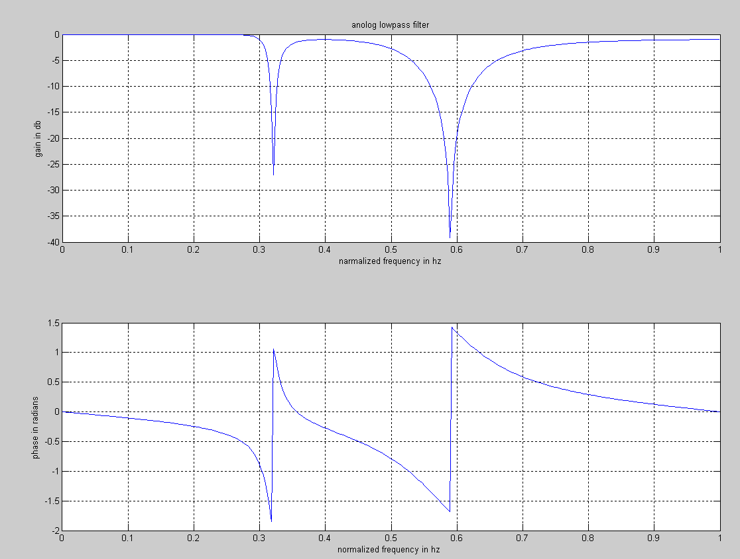

- Chebyshev type2 high pass filter:-

alphap=input('enter the pass band attenuation in db = ');
alphas=input('enter the stop band attenuation in db = ');
wp=input('enter the stop band frequency in rad = ');
ws=input('enter the pass band frequency in rad= ');
[n,wn]=cheb2ord(wp/pi,ws/pi,alphap,alphas);
[b,a]=cheby2(n,alphap,wn,'high');
w=0:0.01:pi;
[h,om]=freqz(b,a,w);
gain=20*log10(abs(h));
ang=angle(h);
subplot(2,1,1);
plot(om/pi,gain);
grid;
xlabel('narmalized frequency in hz');
ylabel('gain in db');
title('anolog lowpass filter');
subplot(2,1,2);
plot(om/pi,ang);
grid;

ylabel('phase in radians');
xlabel('normalized frequency in hz ');

Input values:-

enter the pass band attenuation in db = 1
enter the stop band attenuation in db = 15
enter the stop band frequency in rad = 0.2*pi
enter the pass band frequency in rad= 0.3*pi

Output waveforms:-

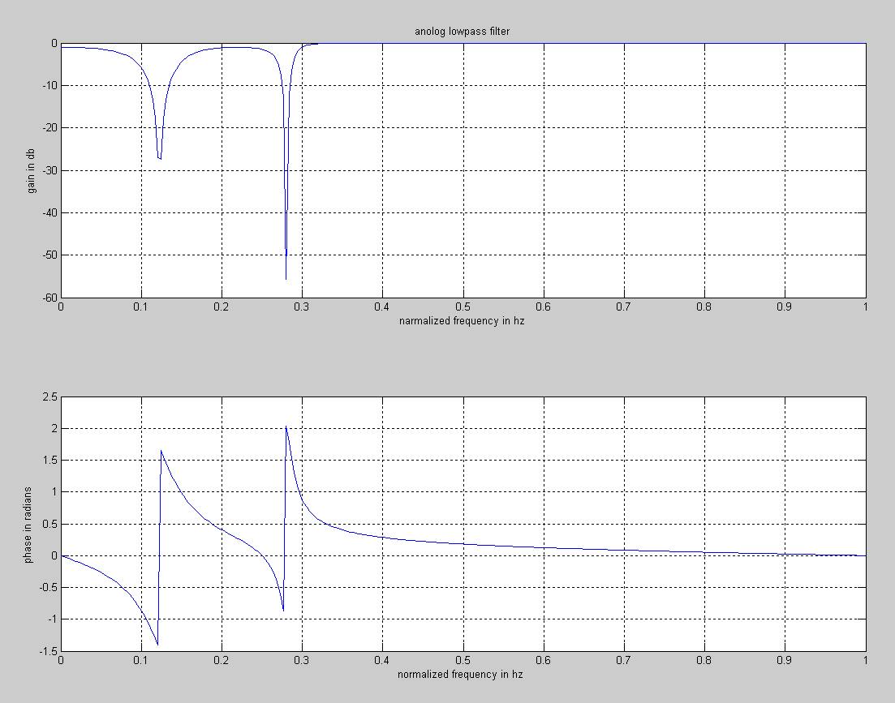

Result:-
Designing of IIR filter from analog has been simulated and waveforms are verified.

3. MAXIMAL SEQUENCE & GOLD SEQUENCE

Aim:-
To generate the maximal sequences and gold sequences.
Software Required:- PC with MATLAB 7.6.0 version
Theory:-
A maximum length sequence (MLS) is a type of pseudorandom binary sequence.
They are bit sequences generated using maximal linear feedback shift registers and are so called because they are periodic and reproduce every binary sequence that can be reproduced by the shift registers (i.e., for length-m registers they produce a sequence of length 2m − 1). A MLS is also sometimes called an n-sequence or an m-sequence. MLSs are spectrally flat, with the exception of a near-zero DC term.
These sequences may be represented as coefficients of irreducible polynomials in a polynomial ring over Z/2Z.
Practical applications for MLS include measuring impulse responses (e.g., of room reverberation). They are also used as a basis for deriving pseudo-random sequences in digital communication systems that employ direct-sequence spread spectrum and frequency-hopping spread spectrum transmission systems, and in the efficient design of some MRI experiments
Generation of maximum length sequences
Figure 1: The next value of register a3 in a feedback shift register of length 4 is determined by the modulo-2 sum of a0 and a1.
MLS are generated using maximal linear feedback shift registers. An MLS-generating system with a shift register of length 4 is shown in Fig. 1. It can be expressed using the following recursive relation:
where n is the time index, k is the bit register position, and + represents modulo-2 addition.
As MLS are periodic and shift registers cycle through every possible binary value (with the exception of the zero vector), registers can be initialized to any state, with the exception of the zero vector.
A Gold code, also known as Gold sequence, is a type of binary sequence, used in telecommunication (CDMA) and satellite navigation (GPS). Gold codes are named after Robert Gold. Gold codes have bounded small cross-correlations within a set, which is useful when multiple devices are broadcasting in the same range. A set of Gold code sequences consists of 2n − 1 sequences each one with a period of 2n − 1.
A set of Gold codes can be generated with the following steps. Pick two maximum length sequences of the same length 2n − 1 such that their absolute cross-correlation is less than or equal to 2(n + 2) / 2, where n is the size of the LFSR used to generate the maximum length sequence (Gold '67). The set of the 2n − 1 exclusive-ors of the two sequences in their various phases (i.e. translated into all relative positions) is a set of Gold codes. The highest absolute cross-correlation in this set of codes is 2(n + 2) / 2 + 1 for even n and 2(n + 1) / 2 + 1 for odd n.
The exclusive or of two Gold codes from the same set is another Gold code in some phase.
If l is odd, t = 2(l+1)/2 + 1, and
If l is even, t = 2(l+2)/2 + 1.
Thus, a Gold sequence formally is an arbitrary phase of a sequence in the set G(u,v) defined by
G(u,v)= {u,v,u * v, u * Tv, u *T2 v, U * T(N-1) v}
Tk denotes the operator which shifts vectors cyclically to the left by k places, * is the exclusive OR operator and u, v are m-sequences of period generated by different primitive binary polynomials.
Program:-
clc;
clear all;
m=input('enter the size of shift registers m =');
N=2^m-1;
tt=-N+1:1:N;
x=ones(1,m);
x1=x;
taps1=input('enter the taps1 =');
taps2=input('enter the taps2 =');
for i=1:N
y1(i)=x1(m);
x2=xor12(x1,taps1);
x1=[x2 x1(1:m)];
end
%disp(y1);
%%%Test-1
T1=sum(y1);
disp('total number of of 1s in maximalseq1 1s');
disp(T1);
if(T1==2^(m-1))
disp('maximal sequence is exist between the selected taps1');
else
disp('maximal sequence is NOT exist between the selected taps1');
end
%%%test2
sy1=2*y1-1;
s1=correlation11(sy1,sy1);
figure(1);
plot(tt,s1);
title('Auto correlation of Maximal sequence1');
xlabel('no of samples---->');
ylabel('magnitude---->');
grid;
%%%2nd maximal sequences
for i=1:N
y2(i)=x(m);
x2=xor12(x,taps2);
x=[x2 x(1:m)];
end
%disp(y2);
%%%Test-1
T2=sum(y2);
disp('total number of of 1s in maximalseq2 1s');
disp(T2);
if(T2==2^(m-1))
disp('maximal sequence is exist between the selected taps2');
else
disp('maximal sequence is NOT exist between the selected taps2');
end
%%%test2
sy2=2*y2-1;
s2=correlation11(sy2,sy2);
figure(2);
plot(tt,s2);
title('Auto correlation of Maximal sequence2');
xlabel('no of samples---->');
ylabel('magnitude---->')
grid;
if(T1==T2)
%module-2 of 2'maximalseq is given as gold sequences(y)
y=xor(y1,y2);
g1=2*y-1;
%%%to check 3-value cross correlation function
x=correlation11(sy1,sy2);
figure(3);
plot(tt,x);
title('cross correlation of MLS1&MLS2');
xlabel('no of samples---->');
ylabel('magnitude---->')
grid;
%%% autocorrelation of gold sequences
xx=correlation11(g1,g1);
figure(4);
plot(tt,xx);
title('auto correlation of gold sequenceses');
xlabel('no of samples---->');
ylabel('magnitude---->')
grid;
disp('gold sequences is exist between the selected taps');
else
disp('gold sequences is NOT exist between the selected taps');
end

%%%gold sequence testing by find corss correlation function
c=input('enter the MLsequence1 or MLSequence2 c=');
if(c==1)
seq=sy1;
else
seq=sy2;
end
nn=input('enter the No shift we want nn=');
yz=2*y-1;
yz1=circshift(yz,[0,nn]);
Y=correlation11(seq,yz1);
%disp(Y);
figure(5);
plot(tt ,Y);
title('3-value checking of goldsequence ');
xlabel('No of samples ');
ylabel('magnitude');
grid;

xor12 sub function:-

function z=xor12(s,t)
n=length(t);
c(1)=xor(s(t(1)),s(t(2)));
for i=1:n-2
c(i+1)=xor(s(t(i+2)),c(i));
end
z=c(length(c));
end

correlation sub function:-

function res=correlation11(x,y)
%%%right shift operation
zzz=0;
for i=1:length(x)
rx=circshift(x,[1,i]);
z=y.*rx;
zz=sum(z);
zzz=[zzz zz];
end
zzz(:,1)=[];

%%%left shift operation
zzz1=0;
for i=1:length(x)
rx=circshift(x,[1,-i]);
z=y.*rx;
zz=sum(z);
zzz1=[zzz1 zz];
end
zzz1(:,1)=[];
total=[(zzz1) zzz];
res=total;
end

Output Results:-

enter the size of shift registers m =7
enter the taps1 =[7 1]
enter the taps2 =[7 3]
total number of of 1s in maximalseq1 1s 64
maximal sequence is exist between the selected taps1
total number of of 1s in maximalseq2 1s 64
maximal sequence is exist between the selected taps2
gold sequences is exist between the selected taps
enter the MLsequence1 or MLSequence2 c=1
enter the No shift we want nn=23

Figure 1:-
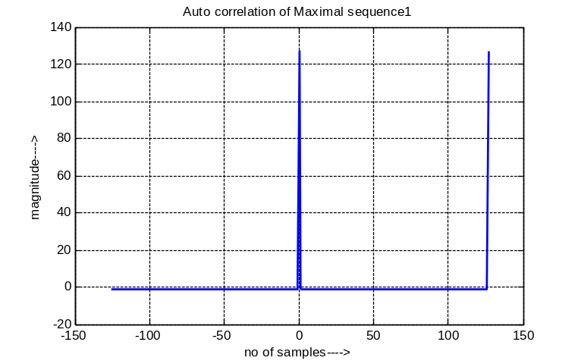

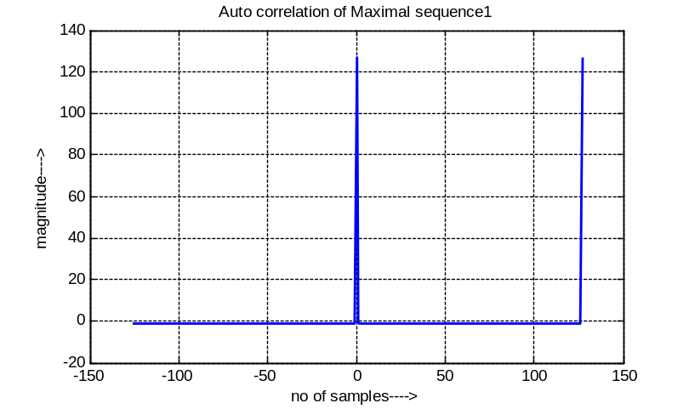

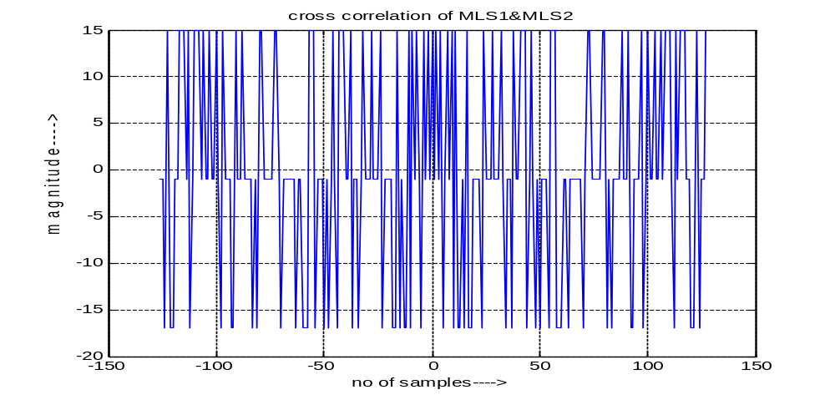
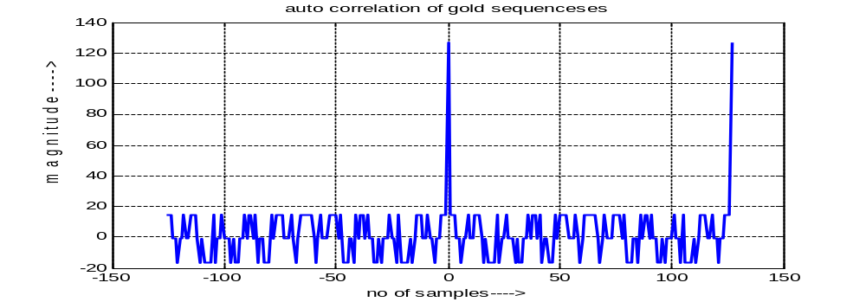
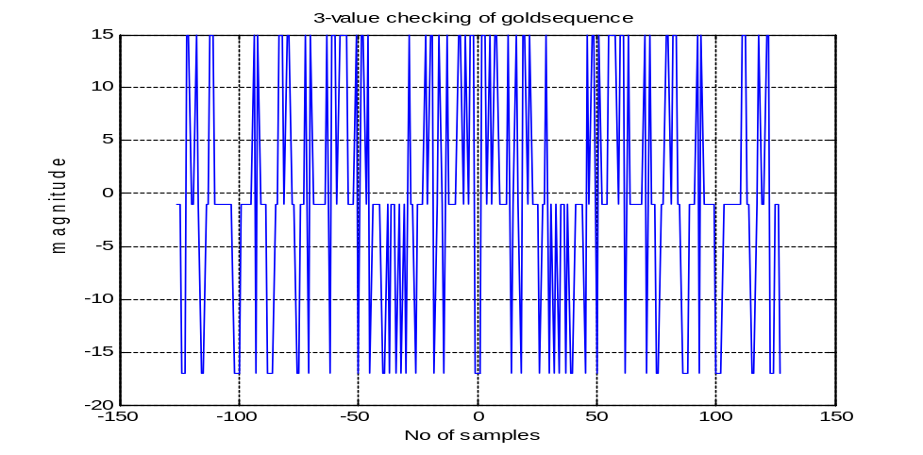
Result:-
Simulation and verification of Maximal and Gold Sequence, has been verified.

4. Rayleigh Fading Channel By Using JAKE’S or CLARKE’S Model

Aim:- To Simulate the Rayleigh Fading Channel using Jake’s Model for different Doppler Spreads (ex:50Hz and 100Hz).

Software Required:- PC with MATLAB 7.6.0.
Theory:-
Rayleigh fading is a statistical model for the effect of a propagation environment on a radio signal, such as that used by wireless devices.
Rayleigh fading models assume that the magnitude of a signal that has passed through such a transmission medium (also called a communications channel) will vary randomly, or fade, according to a Rayleigh distribution — the radial component of the sum of two uncorrelated Gaussian random variables.
Rayleigh fading is viewed as a reasonable model for tropospheric and ionospheric signal propagation as well as the effect of heavily built-up urban environments on radio signals. Rayleigh fading is most applicable when there is no dominant propagation along a line of sight between the transmitter and receiver. If there is a dominant line of sight, Rician fading may be more applicable.
Rayleigh fading is a reasonable model when there are many objects in the environment that scatter the radio signal before it arrives at the receiver. The Central limit Therom holds that, if there is sufficiently much scatter, the channel impulse response will be well-modeled as Gaussian process irrespective of the distribution of the individual components. If there is no dominant component to the scatter, then such a process will have zero mean and phase evenly between 0 and 2π radians. The envelope of the channel response will therefore be Rayleigh.
Calling this random variable R, it will have a probability density function.
Where Ω = E(R2).
Often, the gain and phase elements of a channel's distortion are conveniently represented as a complex number. In this case, Rayleigh fading is exhibited by the assumption that the real and imaginary parts of the response are modelled by independent and identically distributed zero-mean Gaussian processes so that the amplitude of the response is the sum of two such processes.

JAKE’S Model Diagram:-
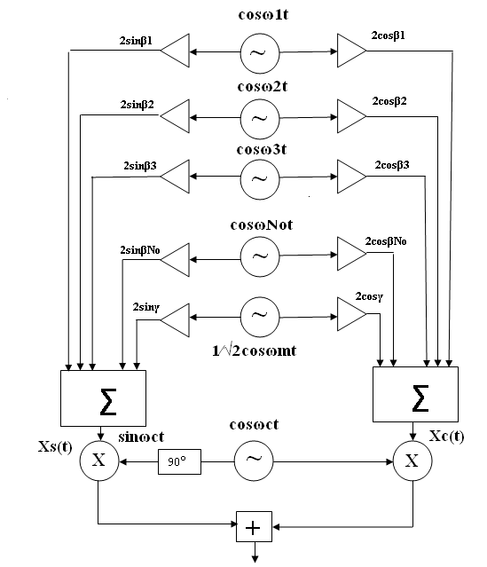
Jakes' model:-
Jakes popularized a model for Rayleigh fading based on summing sinusoids. Let the scatterers be uniformly distributed around a circle at angles αn with k rays emerging from each scatterer. The Doppler shift on ray n is and, with M such scatterers, the Rayleigh fading of the kth waveform over time t can be modeled as: .
Here, and the and are model parameters with usually set to zero, chosen so that there is no cross-correlation between the real and imaginary parts of R(t): and used to generate multiple waveforms. If a single-path channel is being modeled, so that there is only one waveform then can be zero. If a multipath, frequency-selective channel is being modeled so that multiple waveforms are needed, Jakes suggests that uncorrelated waveforms are given by: .
In fact, it has been shown that the waveforms are correlated among themselves — they have non-zero cross-correlation — except in special circumstances. The model is also deterministic (it has no random element to it once the parameters are chosen). A modified Jakes' model chooses slightly different spacing for the scatterers and scales their waveforms using Walsh-Hadamard sequences to ensure zero cross-correlation. Setting
And, Results in the following model, usually termed the Dent model or the modified Jakes model:
The weighting functions Ak(n) are the kth Walsh-Hadamard sequence in n. Since these have zero cross-correlation by design, this model results in uncorrelated waveforms. The phases can be initialized randomly and have no effect on the correlation properties. The Fast Walsh transform can be used to efficiently generate samples using this model.
The Jakes' model also popularized the Doppler spectrum associated with Rayleigh fading, and, as a result, this Doppler spectrum is often termed Jakes' spectrum.
Program:-
- Jakes model:-

clc;
clear all;
N0=8;
N=2*(2*N0+1);
t=250*10^-3;
t1=0:t/(2500):t;
fm=input(' enter the doppler shift frequency fm: ');
wm=2*pi*fm;
gamma=1;
fc=900*10^6;
pw1=0;
for s=0:(t/(2500)):t;
xca=0;
xsa=0;
i=1:N0;
wn=wm.*cos(2*pi*i/N);
bt=(pi*i/N0);
for i=1:N0;
x=cos(wn(i)*s);
xca=xca+x.*2*cos(bt(i));
xsa=xsa+x.*2*sin(bt(i));
end
x1=0.707*cos(2*pi*fm*s);
x1ca=x1*2*cos(gamma);
x1sa=x1*2*sin(gamma);
xc=xca+x1ca;
xs=xsa+x1sa;
y=xs.*sin(2*pi*fc*s)+xc.*cos(2*pi*fc*s);

%disp(y)
z=y.^2;
pw=10*log10(z);
pw1=[pw1 pw];
end
%disp(pw1);
plot(pw1(2:length(pw1)));
title('reyleigh fading channel by using jakes model');
xlabel('samples');
ylabel('power(db)');
%axis([0 120 -50 20]);
grid;

Input values:-

enter the doppler shift frequency fm: 100

output:-

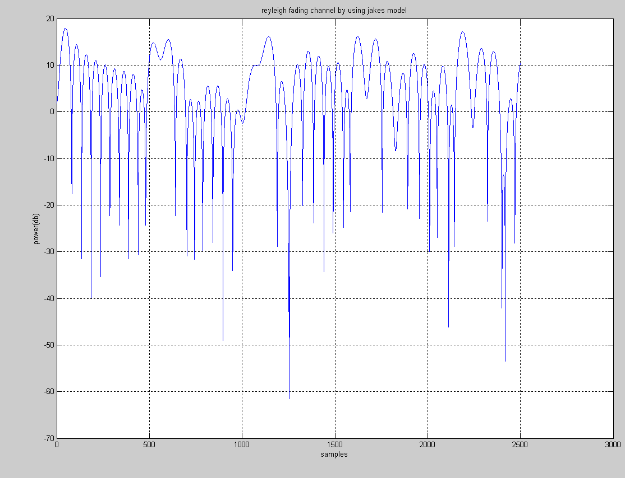

- CLARKE’S MODEL FOR DIFFERENT DOPPLER SPREAD
Spectral shape due to Doppler spread in Clarke’s model: Developed spectrum analysis for Clarke’s model. Let P (α)d α denote the function of the total incoming power with in dα of the angle α and let A denote the average received power with respect to an isotropic antenna . As N→∞, P (α) dα approaches a continuous, rather than a discrete ,distribution . If G (α ) is the azimuthal gain pattern of the mobile antenna as a function of the angle of arrival, the received power can be expressed as
P_{r}=∫A G(α ) P(α)d α
The spectrum is centred on the carrier frequency and is zero outside the limits of f_{c}±f_{m}. Each of the arriving waves has its own carrier frequency (due to its direction of arrival) which is slightly offset from the center frequency .For the case of a vertical λ/4 antenna (G(α )=1.5) and a uniform distribution P(α)=1/2π over 0 to 2π output spectrum is given by
S_{E} (f)=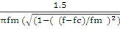
Steps to implement the Clarke’s simulator:-
- Specify the number of frequency domain points (N) used to represent sqrt(s_{E}(f)) and the maximum Doppler frequency Shift (f_{m}). The value used for N is usually a power of two.
- Compute the frequency spacing between adjacent spectral lines as ∆f=2fm/(N-1). This defines the time duration of a fading waveform T=1/∆f.
- Generate complex Gaussian random variables for each of the N/2 +ve frequency components of the noise source by conjugating positive frequency values and assigning these of negative frequency values.
- Multiply the in phase and quadrature noise sources by the fading spectrum. Sqrt (s_{E}(f)).
- Perform an IFFT on the resulting frequency domain signals from the in phase and quadrature arms to get two N-length time series, and add the squares of each signal point in time to create an N-point time series like under the radical of equation
- |E₂(t)|= =r(t)
- Take the square root of the sum obtained in step6 to obtain an N-point time series of a simulated Rayleigh fading signal with the power Doppler spread and time correlation.
Program:-
%clearks simulation methodology for multipath fading channel
clc;
clear all;
N=input('enter the no value of N=');

x1=1/sqrt(2).*randn(1,N/2);
y1=1/sqrt(2).*randn(1,N/2);
f1=(x1+y1*i);
r1=fliplr(conj(f1));
d1=[r1 f1];
%stem(d1);
sell=0;
fm=166;
fc=1800*10^6;
se11=0;
for f=0:(2*(fm)/(N-1)):(fm);
se1=1.5./(pi*fm*(sqrt(1-((f)/fm)^2)));
se11=[se11 se1];
end
se11=se11(2:length(se11));
se12=fliplr(se11);
se13=[se12 se11];
serslt11=sqrt(se13);
mul11=mult(d1,serslt11);
mul13=ifft(mul11);
mul15=real(mul13);
mul17=(mul15).^2;

x2=1/sqrt(2).*randn(1,N/2);
y2=1/sqrt(2).*randn(1,N/2);
f2=(x2+y2*i);
r2=fliplr(conj(f2));
d2=[r2 f2];
%stem(d2);
se21=0;
for f2=0:(2*(fm)/(N-1)):(fm);
se2=1.5./(pi*fm*(sqrt(1-((f2)/fm)^2)));
se21=[se21 se2];
end
se21=se21(2:length(se21));
se22=fliplr(se21);
se23=[se22 se21];
serslt21=sqrt(se23);
mul21=mult(serslt21,d2);
mul23=ifft(mul21);
mul25=real(mul23);
mul27=(mul25).^2;
summation=plus(mul27,mul17);
result=sqrt(summation);
power=20*log10(result);
%figure
%plot(power);
normalized=result/max(result);
power1=10*log10(normalized);
figure
plot(power1);
axis tight;
title('CLEARKES SIMULATION METHODOLOGY');
xlabel('samples------------>');
ylabel('NORMALIZED POWER(dB)----->');

Output Results:-

enter the no value of N=1024

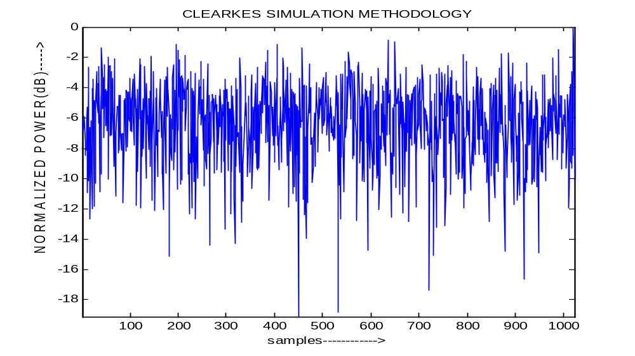

Result:-
Rayleigh Fading channel generated using Clarke’s & Jake’s Model for different Doppler Spreads are simulated and verified.

- PERFORMANCE EVALUATION OF QPSK OVER AWGN
Aim:- To simulate and verify the performance evaluation of QPSK over AWGN channel.
Software Used:- Pc with MATLAB 7.6.0.
Theory:-
Transmission power and channel Bandwidth are the two main resources in communication systems.
- The channel Bandwidth depends on the Bit Rate or signaling rate fb.
- If two or more bits are combined in some symbols then the signaling rate will be reduced. Thus the frequency of the carrier needed is also reduced.
- This reduces the Transmission channel Bandwidth.
- In QPSK two bits are combined and hence there is the existence of 4 symbols possible with each symbol changing there exists the phase of the carrier changed by π/4 radians.
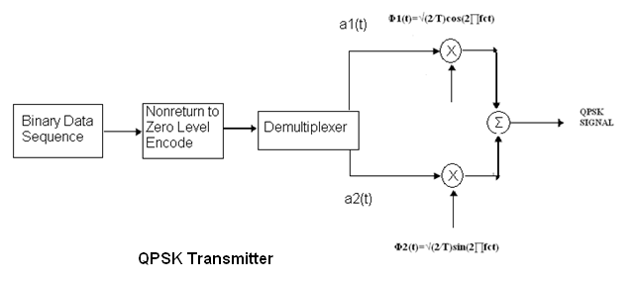
Generation of QPSK:-
- Here the Binary sequence is transformed from 1’s and 0’s to 1’s.
- Then the symbol duration would be of 2Tb with Bandwidth fb.
- Thus this symbol duration consists of even and odd numbered sequence which is then multiplied by the carrier signal of sin(2πfct) and cos(2πfct). For even and odd sequence.
Se(t) = be(t)*sin(2πfct)
So(t) = bo(t)*cos(2πfct)
- Then these two signals Se(t) and So(t) are added through adder.
S(t) = b(t)*fct)+be(t)fct)
Reception of QPSK:-
- In this Receiver section the QPSK signal is received at the Receiver and thus the Received signal is added with channel noise (AWGN channel)
- Then the signal is again multiplied by the carrier with both sides of sin(2πfct) and cos(2πfct) .
- Then it is passed towards the Low pass filter to eliminate high freq: components and finally the I and Q bits are arranged in order.
Probability of Error:-
- The Pe is that the error probability that exists by this communication system.
- Thus the Pe for QPSK is being defined by plotting Pe by Eb/No in dB on x-axis through semilogaritham.
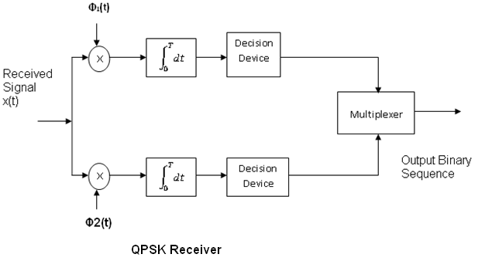

Program:-

QPSK_AWGN:

clc;
clear all;
close all;
N=input('enter the number of bits to be transmitted: ');
snrdb=0:1:14;
P=zeros(1,N);
for loop=1:1:length(snrdb)
sigmao=10^(snrdb(loop)/20);
Data=(2*(rand(1,N)>0.5)-1)+1i.*(2*(rand(1,N)>0.5)-1);
Nois=(randn(1,N)+1i*randn(1,N))./sqrt(2);
TransData=Data+sigmao.*Nois;
tx1=real(TransData);
tx2=imag(TransData);
for i=1:1:length(tx1)
if (tx1(i)<0)
Yr1(i)=-1;
else
Yr1(i)=1;
end
end
for i=1:1:length(tx2)
if (tx2(i)<0)
Yi1(i)=-1;
else
Yi1(i)=1;
end
end
Rx=Yr1+1i*Yi1;
Er(loop)=length(find(Data-Rx));
qf(loop)=erfc(sqrt(.5*(10.^(snrdb(loop)/10))))-(.25)*(erfc(sqrt(.5*(10.^(snrdb(loop)/10))))).^2;
end
BER=Er./N;
figure(1);
semilogy(snrdb,BER,'-*',snrdb,qf,'-+'),axis([ 0 15 10^(-6) 10^(0)]);
xlabel('snr db -->>');
ylabel('probability of error(BER) -->>');
title('*** probability of error for QPSK ***');
legend('Pe(BER) of QPSK' , 'Q');

Input values:-
enter the number of bits to be transmitted: 15

Output waveforms:-

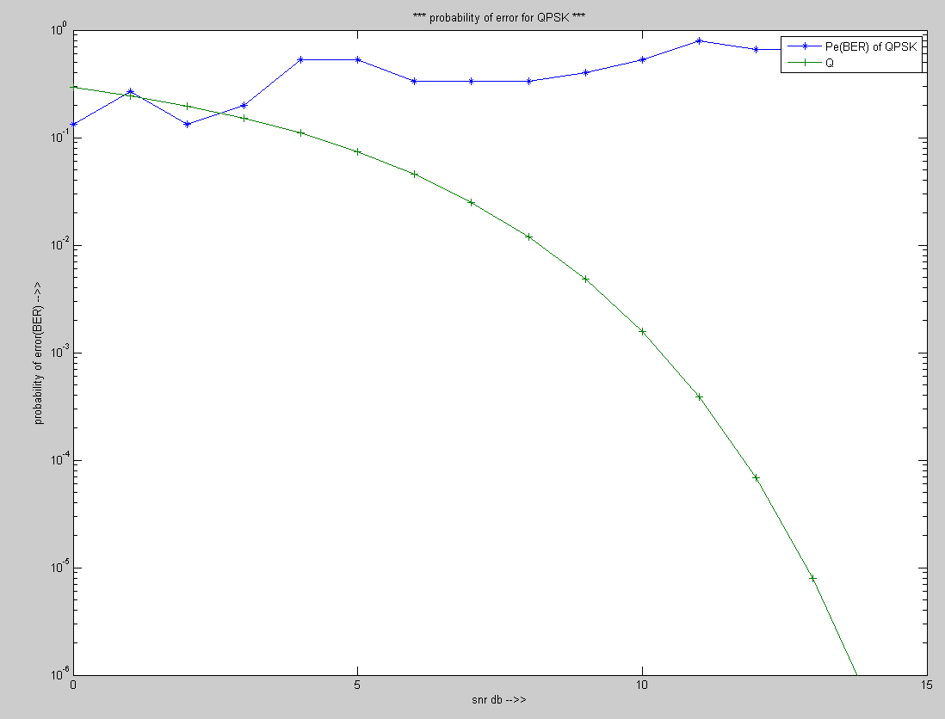

Result:-
Performance evaluation of QPSK system over Gaussian AWGN Channel is simulated and the result is verified.

- PERFORMANCE EVALUATION OF QPSK OVER RAYLEIGH FADING CHANNEL
Aim:- To evaluate the performance of QPSK System over Rayleigh Fading Channel.
Software Required:- Pc with MATLAB 7.6.0
Theory:-
The model simulates QPSK transmission over a multipath Rayleigh fading channel. You can control transmission and channel parameters via workspace variables.
The maximum Doppler shift is computed as v*f/c, where v is the mobile speed, f is the carrier frequency, and c is the speed of light. For example, a maximum Doppler shift of 200 Hz (as above) corresponds to a mobile speed of 65 mph (30 m/s) and a carrier frequency of 2 GHz.
By convention, the delay of the first path is typically set to zero. For subsequent paths, a 1 microsecond delay corresponds to a 300 m difference in path length. In some outdoor multipath environments, reflected paths can be up to several kilometers longer than the shortest path. With the path delays specified above, the last path is 3.6 km longer than the shortest path, and thus arrives 12 microseconds later.
Together, the path delays and path gains specify the channel's average delay profile. Typically, the average path gains decay exponentially with delay (i.e., the dB values decay linearly), but the specific delay profile depends on the propagation environment. In the delay profile specified above, we assume a 3 dB decrease in average power for every 4 microseconds of path delay. We have also selected an option in each channel block's mask dialog to normalize the average path gains so that their collective gain is 0 dB.

Theoretical BER:-
BER = 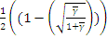 where =

Program:-

% Program for Performance evaluation of QPSK system over Rayleigh Fading Channel
clc;
clear all;
e=1;
snrdb=0:1:40;
L=length(snrdb);
n=1000;sp=10;rb=n*sp;
tb=1/rb;fs=3*rb;ts=1/fs;fc=1*rb;
m=tb/ts;
t=0:ts:((n*tb)/2-ts);
for ii=1:L
pe=0;%pe1=0;
snr=10^((ii-1)/10);
sigmao=sqrt(e/snr);
for s=1:sp
d=rand(1,n)>.5;
d1=d(1:2:n);%ODD TERMS
d2=d(2:2:n);%EVEN TERMS
out1=[];
for i=1:n/2
for j=0:ts/2:(tb-ts)/2
out1=[out1 (-1)^(1+d1(i))];
end
end
out2=[];
for i=1:n/2
for j=0:ts/2:(tb-ts)/2
out2=[out2 (-1)^(1+d2(i))];
end
end
%out=out(2:length(out));
%plot(t,d);
osc1=sin(2*pi*fc*t);
osc2=cos(2*pi*fc*t);
%plot(t,osc);
tx1=osc1.*out1;
tx2=osc2.*out2;
%%summation to transmit data
tx=tx1+tx2;
% figure
% plot(tx)

% AWGN CHANNEL

p=length(tx);
w=jakes(p);
w1=sigmao.*randn(1,length(tx));
%%%rayligh fading channel
%tx11=conv(tx,w);
%tx11=tx11(length(w):end);
rx=w+w1+tx;
%RECEIVER
rx1=rx.*osc1;
rx2=rx.*osc2;
% figure
% plot(rx1)
% length(rx1)
%%%integrator1
ib=0:ts/2:(tb-ts)/2;
for i=0:(length(rx1)/m)-1;
y1(i+1)=trapz(ib,rx1(int32(i*m+1):int32((i+1)*m)));
end
%%%integrater2
ib=0:ts/2:(tb-ts)/2;
for i=0:(length(rx2)/m)-1;
y2(i+1)=trapz(ib,rx2(int32(i*m+1):int32((i+1)*m)));
end
es1=(y1>0);
es2=(y2>0);
es(1:2:n)=es1;
es(2:2:n)=es2;

% for i=1:n
% if(es(i)==d(i))
% else
% pe1=pe1+1;
% end
%
% end disp('data');
% disp(d);
% disp('geting')
% disp(es);
% disp('error is')

for i=1:n
if(d(i)==es(i))
else
pe=pe+1;
end
end

% disp(pe);
% pe=pe+(sum(xor(d,es)));
end
% pe2(ii)=pe1;
% BER(ii)=pe2(ii)/(n*sp);
pe1(ii)=pe;
BER(ii)=pe1(ii)/(n*sp);
geta=mean(abs(w))*ii;
%geta=G*(sum(bfad.*bfadt)/sigmao^2);
qf4(ii)=0.5*(1-sqrt(geta/(1+geta)));
%qf4(ii)=2*qfunc(sqrt(snr));
end
%disp(pe2);
% disp(pe1);
disp('bit error rate is');
disp(BER);
%disp(ber);
semilogy(snrdb,BER,'-o',snrdb,qf4,'-+');
hold all;
axis([ 0 40 10e-7 10e-1 ]);
legend('BER','Q');
grid;

%Sub function for Jakes for Rayleigh Fading Channel Generation.
function z=jakes(h)
%clc
%clear all;
N0=8;
N=2*(2*N0+1);
t=250e-9;
fm=100;%input('')
wm=2*pi*fm;
r=0;
fc=900e6;
s=0:t/h:t-(t/h);
xca=0;xsa=0;
i=1:N0;
wn=wm.*cos(2*pi*i/N);
bt=(pi*i/N0);
for i=1:N0
x=cos(wn(i).*s);
xca=xca+x.*2*cos(bt(i));
xsa=xsa+x.*2*sin(bt(i));
end;
x1=0.707*cos(2*pi*fm*s);
x1ca=x1*2*cos(r);
x1sa=x1*2*sin(r);

xc=xca+x1ca;
xs=xsa+x1sa;
y=xs.*sin(2*pi*fc*s)+xc.*cos(2*pi*fc*s);
%z=y.^2;
%z=z/max(z);
%pw=10*log10(z);
title('QPSK by using Rayleigh Fading Channel');
xlabel('Eb/N0(dB)-->>');
ylabel('Pe(BER) -->>');
legend('BER','Q');
%disp(pw1);plot(y);axis tight;
z=y;
end

Output Result:-

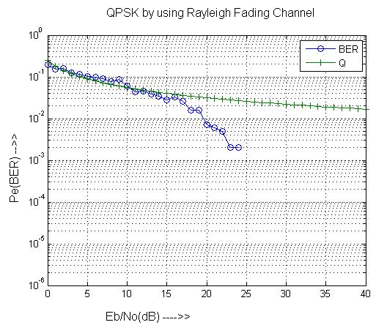

Result:-
Performance evaluation of QPSK System over Rayleigh fading channel is simulated and results are verified.

- PERFORMANCE EVALUATION OF RAKE RECEIVER OVER SLOW FADING CHANNEL
Aim:- To evaluate the performance of RAKE receiver over slow fading channel.
Software Required:- Pc with MATLAB 7.6.0
Theory:-
A rake receiver is a radio receiver designed to counter the effects of multipath fading. It does this by using several "sub-receivers" called fingers, that is, several correlators each assigned to a different multipath component. Each finger independently decodes a single multipath component; at a later stage the contribution of all fingers are combined in order to make the most use of the different transmission characteristics of each transmission path. This could very well result in higher signal-to-noise ratio (or Eb/N0) in a multipath environment than in a "clean" environment.
The multipath channel through which a radio wave transmits can be viewed as transmitting the original (line of sight) wave plus a number of multipath components. Multipath components are delayed copies of the original transmitted wave traveling through a different echo path, each with a different magnitude and time-of-arrival at the receiver. Since each component contains the original information, if the magnitude and time-of-arrival (phase) of each component is computed at the receiver (through a process called channel estimation), then all the components can be added coherently to improve the information reliability.
The rake receiver is so named because it reminds the function of a garden rake, each finger collecting symbol energy similarly to how tines on a rake collect leaves.
Rake receivers are common in a wide variety of CDMA and W-CDMA radio devices such as mobile phones and wireless LAN equipment.

Rake Receiver Diagram:-

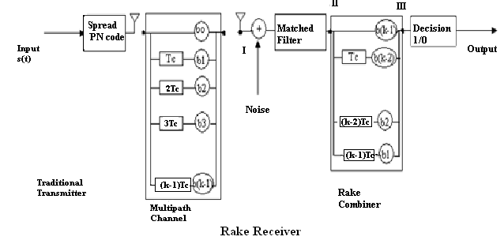

Rake receiver:-
If, in a mobile radio channel reflected waves arrive with small relative time delays, self interference occurs. Direct Sequence (DS) Spread Spectrum is often claimed to have particular properties that makes it less vulnerable to multipath reception. In particular, the rake receiver architecture allows an optimal combining of energy received over paths with different. It avoids wave cancellation (fades) if delayed paths arrive with phase differences and appropriately weighs signals coming in with different signal-to-noise ratios.
The rake receiver consists of multiple correlators, in which the receive signal is multiplied by time-shifted versions of a locally generated code sequence. The intention is to separate signals such that each finger only sees signals coming in over a single (resolvable) path. The spreading code is chosen to have a very small autocorrelation value for any nonzero time offset. This avoids crosstalk between fingers. In practice, the situation is less ideal. It is not the full periodic autocorrelation that determines the crosstalk between signals in different fingers, but rather two partial correlations, with contributions from two consecutive bits or symbols. It has been attempted to find sequences that have satisfactory partial correlation values, but the crosstalk due to partial (non-periodic) correlations remains substantially more difficult to reduce than the effects of periodic correlations.

The rake receiver is designed to optimally detect a DS-CDMA signal transmitted over a dispersive multipath channel. It is an extension of the concept of the matched filter.
In a multipath channel, delayed reflections interfere with the direct signal. However, a DS-CDMA signal suffering from multipath dispersion can be detected by a rake receiver. This receiver optimally combines signals received over multiple paths.
Like a garden rake, the rake receiver gathers the energy received over the various delayed propagation paths. According to the maximum ratio combining principle, the SNR at the output is the sum of the SNRs in the individual branches, provided that
- we assume that only AWGN is present (no interference)
- codes with a time offset are truly orthogonal

Program:-
clc;
clear all;
e=1;
snrdb=0:1:20;
n=1000;
L=length(snrdb);N=7;code=[1 1 1 -1 -1 1 -1];G=7;chipsperslot=7;
bfad=randn(1,10);%[0.1 -0.2 0.3];
bfadt=conj(fliplr(bfad));%[0.3 -0.2 0.1];

t=0:ts:((n*tb/2)-ts);
sp=10;
for ii=1:L
pe1=0;
snr=10^((ii-1)/10);
sigmao=sqrt(sum(bfad.*bfadt)*G/snr);
%%%data generater
d=rand(1,n)>.5;
d1=2*d-1;
%%%%SPREADING THE DATA
% out=conv(d1,code);
out=[];
for i=1:n
out=[out d1(i)*code];
end

K=length(bfad);
mfdata=conv(out,bfad);
% %% AWGN CHANNEL
w=sigmao.*randn(1,length(mfdata));
rx=w+mfdata;
% %%AT RECEIVER SIDE
%%%matched filter
mfdata1=conv(rx,conj(fliplr(bfad)));
%delay=length(code)+length(bfad);
getdata=mfdata1(3:length(mfdata1)-2);
%getdata=mfdata1(delay:delay+chipsperslot);
%getdata=getdata(K:length(code):length(getdata));
rdata=getdata;
for i=1:n
rdata(i)= getdata(((K)+(i-1)*N));
end
rd=rdata>0;
for i=1:n
if(rd(i)==d(i))
else
pe1=pe1+1;
end
end

pe2(ii)=pe1;
%%probability error in simulated system
BER(ii)=pe2(ii)/(n);
%%probability error in theoretical function
geta=G*(sum(bfad.*bfadt)/sigmao^2);
qf4(ii)=0.5*(1-sqrt(geta/(1+geta)));
end
disp(pe2);
disp(qf4);
disp('bit error rate is');
disp(BER);
semilogy(snrdb,BER,'-o',snrdb,qf4,'-+');
hold all;
%axis([0 14 10e-7 10e-1]);
legend(' praticalBER','theoreticalBER');
title('BER performance of RAKE Receiver')
xlabel('snrdb--->');
ylabel('Pe--->');
grid;

Output Result:-

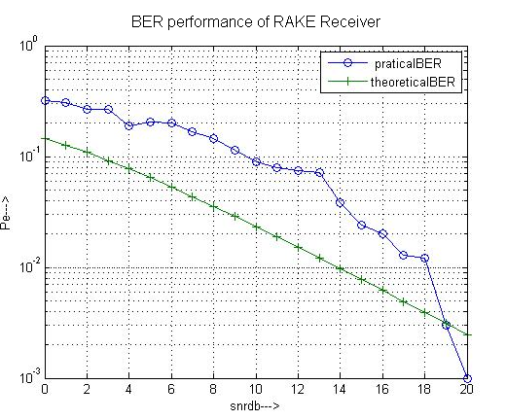
Result:-
Performance evaluation of RAKE Receiver is been simulated and verified.

